5.2.1 Line Integrals

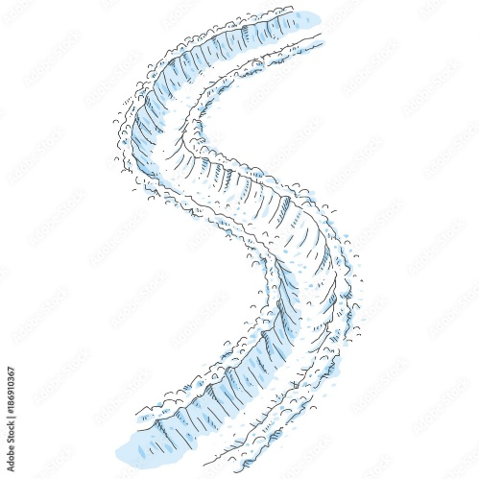
Motivation: Suppose we just experienced a snowstorm and there is snow everywhere outside. In some spots the snow is higher and in some spots it is lower. You want to walk out into the snow, shoveling as you go, so that you can reach your car. In this scenario, how much snow do we actually have to shovel? This entirely depends on the path that we take to reach our car. How long the path is has an effect, but also the amount of snow that our specific path will take us through.

A line integral (or what is sometimes referred to as a path integral) captures this idea of accumulation of a specific quantity over a path. More specifically, suppose that we plan to move along a curve C in 3-space and measures the amount of some quantity that occurs at each point along the path C. A line integral would help us to determine the accumulation of over the curve C.

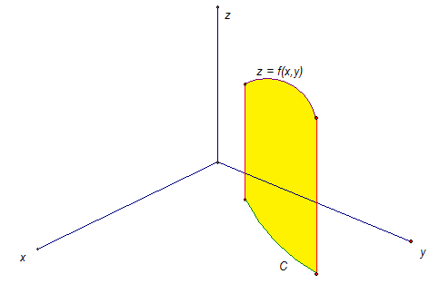
Exploration: Suppose that the continuous function measures the amount of “quantity” that occurs at each point along a smooth plane curve C and we want to add up the amount of “quantity” that occurs as we move along the curve. Note: This is the same as saying that we want the area of the “curtain” formed by over C. A possible picture of the situation is shown below (the “curtain” is in yellow).

In the picture the green curve C lies completely on the xy-plane and the purple curve is the result when only points on C are plugged into .

To estimate the area of the “curtain” we partition into n subintervals of the form each of width .
We can use this partition to partition the curve C, if we plot each point on C

Then, we let be the length of the line segment from to .
We select a sample point from each interval, and we then acts as a representative height of the sheet at this point.

Then, an approximation of our “curtain” area is:

This leads to the following definition.
Definition: If is defined on a smooth curve C, then the line integral of f along C is

provided this limit exists.

Note: In later sections we will want to extend this idea to adding up quantities as we move across a surface.

Example 1: Suppose a wire can be modelled by the upper half of the unit circle given by . If the linear density of this wire is measured by for any point on the wire, then set up an integral which represents the mass of this wire.
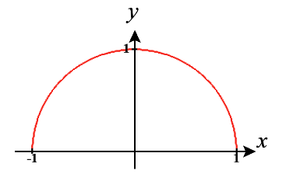

We know that the mass of the wire is given by where C is the upper half of the unit circle.

While we may follow the logic of how this integral was constructed it is strange to think about how one would evaluate an integral of this type.

Exploration: We know from chapter 2 that we can parameterize C by where . Suppose we do this and observe the ith segment of the curve C. We see that from section 2.3 the arc length of this segment is given by:
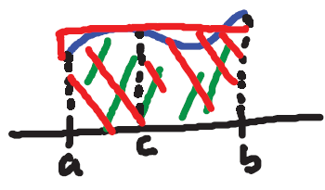
However, we may recall the Mean Value Theorem for Integrals (from Calculus I) which states that for a continuous function
for some c in .

Therefore, by the Mean Value Theorem for Integrals we know that there exists a in such that

So, .
We have transformed the original line integral into an integral which is completely in terms of t!
Fact: If where represents the parameterization of C then,

One important item to note is that the value of the line integral does NOT depend on the parameterization of C (the parameterization was above) provided C is traversed exactly once as t increases from a to b.

Remark: We can further simplify the above formula by noticing that and therefore we have:
.

Example 1 (cont.): Suppose a wire can be modelled by the upper half of the unit circle given by . If the linear density of this wire is measured by for any point on the wire, then set up and evaluate an integral which represents the mass of this wire.

We already established from the first part of this example that
Now we need to parameterize C so that we can get this integral into a state where we can compute its value.

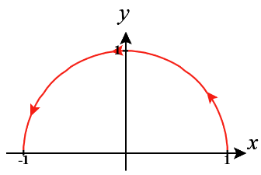
One possible parameterization for the top half of the unit circle is where (Note: Another possible parameterization is where , but this parameterization makes evaluation messier).

So, we have that

Note: As we see in the above examples, one of the biggest challenges in evaluating a line integral can be finding a suitable parameterization for C.
Extensions to 3-Dimensions
All of the notions above extend easily to three dimensions. In particular if C is a smooth space curve given by where and is a three variable function that is continuous on some region containing C, then the line integral of f along C is

Example 2: Suppose you have a pipe in 3-space that follows the path of the curve C parameterized by where . All suppose that the pipe varies in size across length and the cross-sectional area at any point can be given the function . Set up and evaluate an integral which represents the volume of water that can exist within this pipe.

To get the volume we can see that we just want to add up .

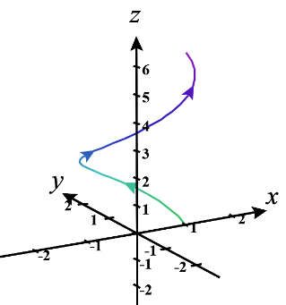
Therefore, the volume is given by

Note: In the special case that , we note that which means that in this case the line integral of f along C is equal to the arc length of C!
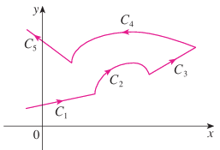
Definition: We say that the curve C is a piecewise-smooth curve if C is the union of a finite number of smooth curves where the initial point of is the terminal point of .

The picture on the right shows a function that is piecewise-smooth and is made up of 5 different curves.

Fact: If the curve C is a piecewise-smooth curve, then we define the integral of along C as the sum of the integrals of along each of the smooth pieces of C.

If C is the union of a finite number of smooth curves where the initial point of is the terminal point of , we write:

Example 3: Suppose that a curve C consists of the arc of the parabola from to followed by the line segment from to . Evaluate .

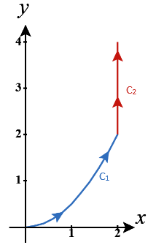
We first note that a parameterization for is where , and a parameterization for is where .

So, we have that

Now, we will go over two different types of line integrals which are important in applications.

Definition:
- If we replace with in the first definition of this lecture, we obtain the line integral of f along C with respect to x: .
- If we replace with in the first definition of this lecture, we obtain the line integral of f along C with respect to y: .

Note: To avoid confusion, we call the line integral defined in our first definition of this lecture the line integral with respect to arc length.

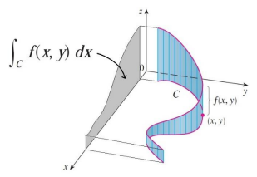
Fact: If C is a smooth curve with parameterization where and is continuous on a region containing C, then
and

Note: If the line integral with respect to the arc length is the size of the “curtain” beneath , you can think of the line integral of f with respect to x or y as the size of the shadow (projection) in the x or y directions. The real significance of line integrals with respect to x, y, and z will be explored in the next section when we look at the relationship between line integrals and the notation of work.

Note: The above definition and fact extend easily to three dimensions where we also have a line integral of f along C with respect to z.

Note: In all cases of line integrals that we have seen (with respect to x, y, z, or arc length) we solve these integrals by parametrizing C in terms of t, and then calculating the integral (and its components) in terms of t.

Notation: Often times line integrals with respect to x and y occur together. When this happens, it is customary to abbreviate as follows: . An analogous abbreviation is used for three line integrals with respect to x, y, and z.

Example 4: Evaluate where C is the line segment from to .
We could find a parameterization for C by using techniques of basic algebra, but it can be faster to find a parameterization through the techniques of chapter 2.

In particular in chapter 2 we learned that a vector equation for the line connecting the terminal points of the position vectors and is where .

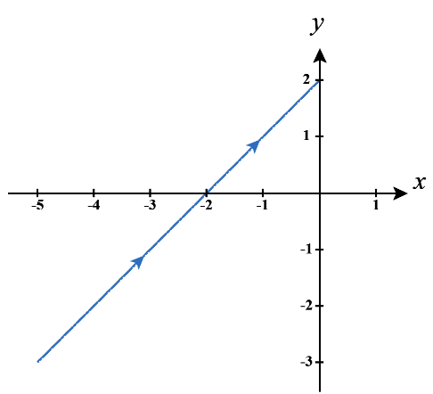
So, using and , we have that:

Question: Would our answer in the above example have changed if we found a parameterization from (0,2) to (-5,-3)? The next example addresses this question.

Notation: Suppose that C is a curve with initial point A and terminal point B. The curve denotes the curve consisting of the same points as C, but with opposite orientation (from initial point B to terminal point A).

Example 5:
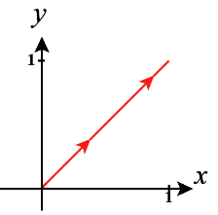
- Suppose that C is given by where . Find .
We calculate that .

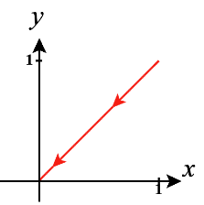
- Suppose that C’ is given by where . Find .
We calculate that .
- Notice that . What would you speculate is the relationship between and ?
Based upon the answers to (a) and (b) we would speculate that .

- What is the relationship between and .
We know from this class that the line integral with respect to arc length does not depend on the parameterization of C provided C is traversed exactly once. So, we have that .

Fact: For line integrals that exist we have that , , and . These facts also extend to three dimensions.

Example 6: Suppose that C is the line segment from to . Evaluate .

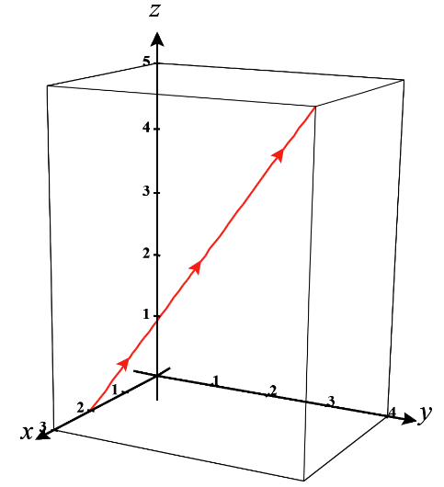
We recall that there are actually three line integrals to evaluate here. In particular, .

If we let and , we know that a parameterization on the line segment from to is: where .
So, we have that the line segment is given by the parametric equations: .
These parametric equations imply that .
So, we have that

